Recyclebot V5 STL Glossary

https://www.sciencedirect.com/science/article/pii/S2468067218300208

Aubrey Woern

2-16-2018

Example File Name:

Control Panel_Side_x2

Assembly Name Part Name Quantity Needed

# Board Assembly

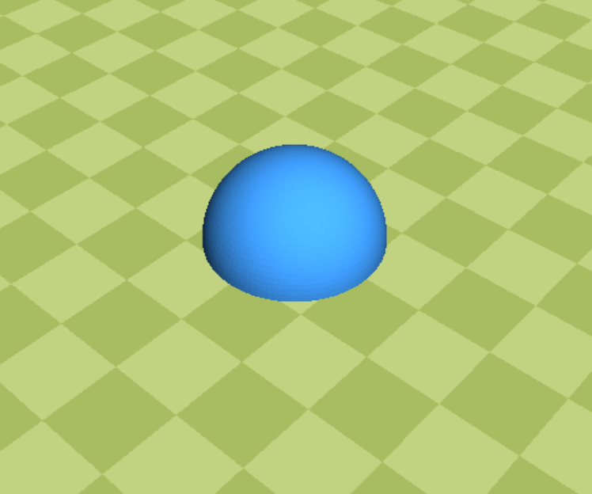

Board_Feet (Ninjaflex)_x4

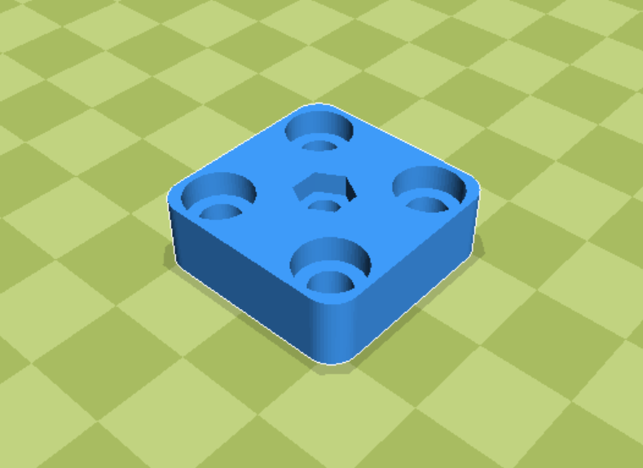

Board_Feet Screw Mount_x4

# Control Panel Assembly

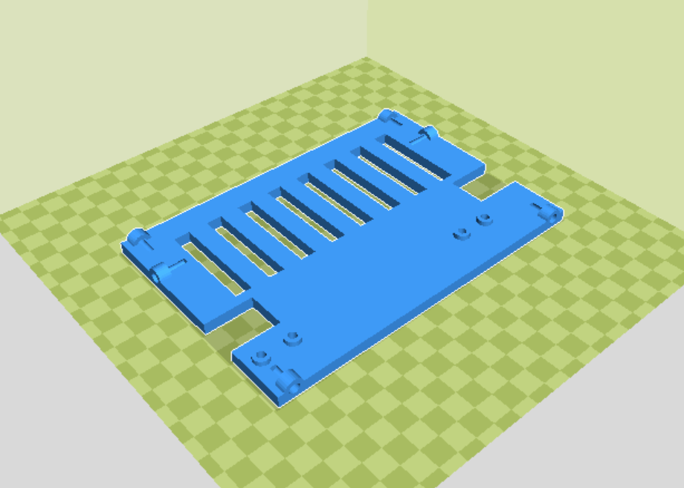

Control Panel_Back_x1

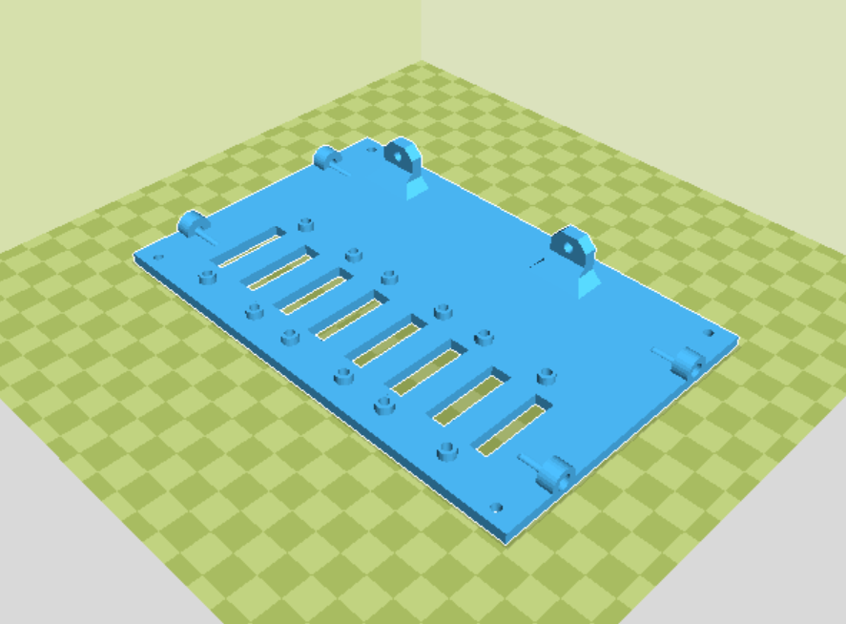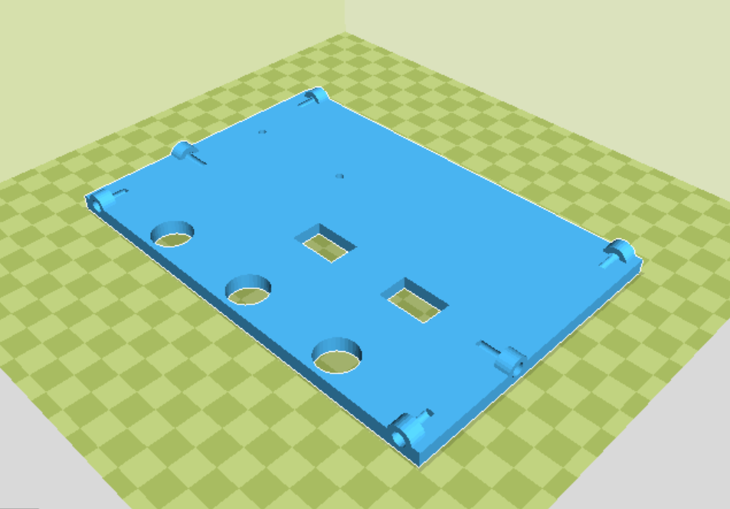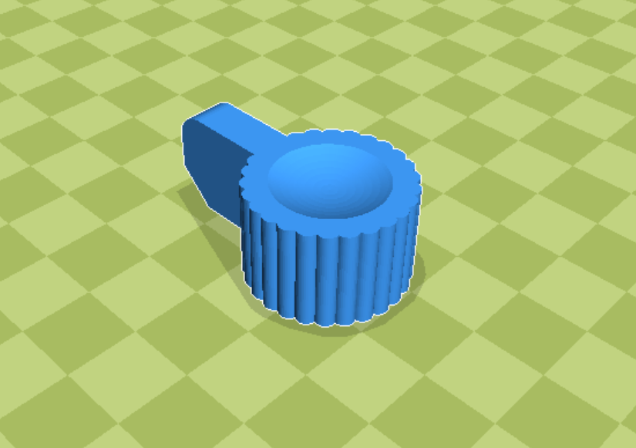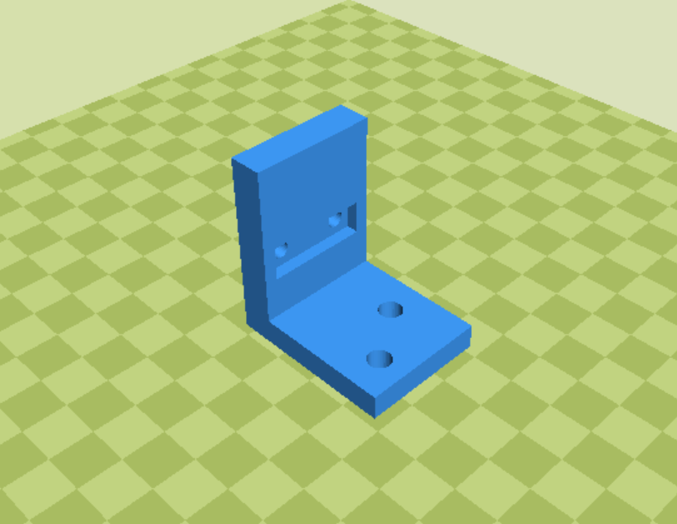

Control Panel_Front_x1

Control Panel_Bottom_x1

Control Panel_Mounting Brackets_x1

Control Panel_LCD Knob_x1

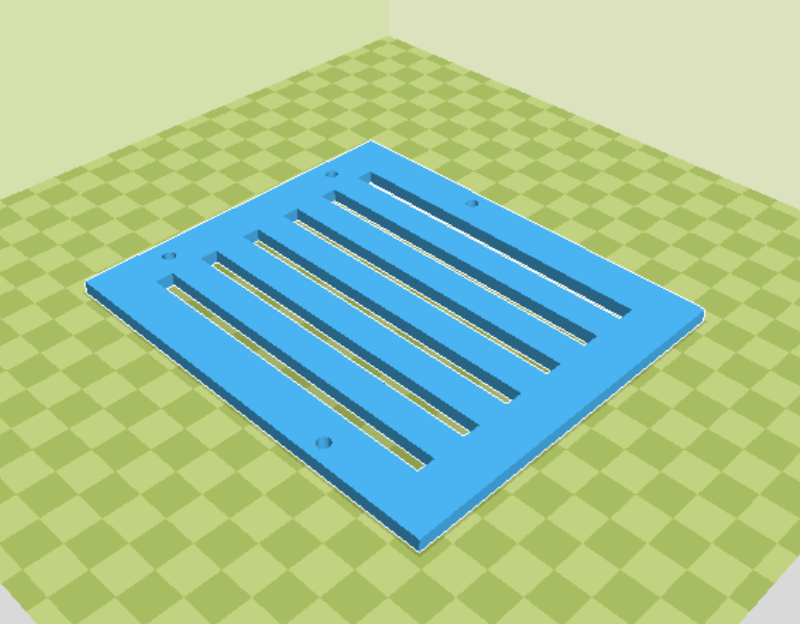

Control Panel_Side_x2

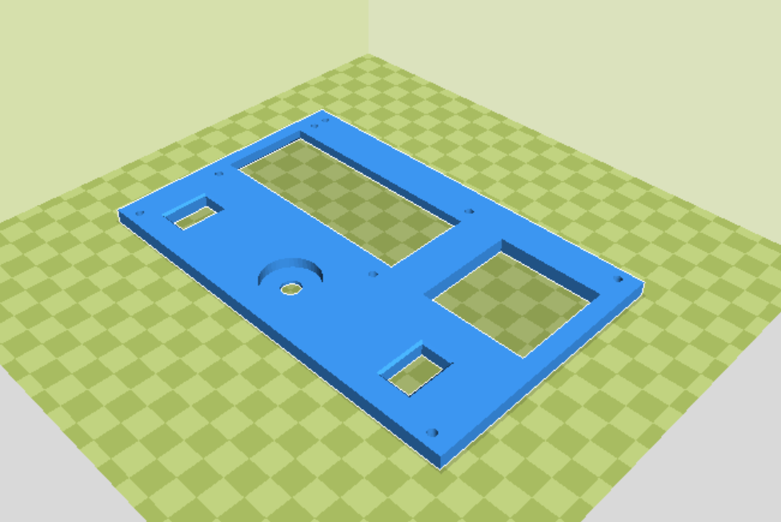

Control Panel_Top_x1

# Cooling Assembly

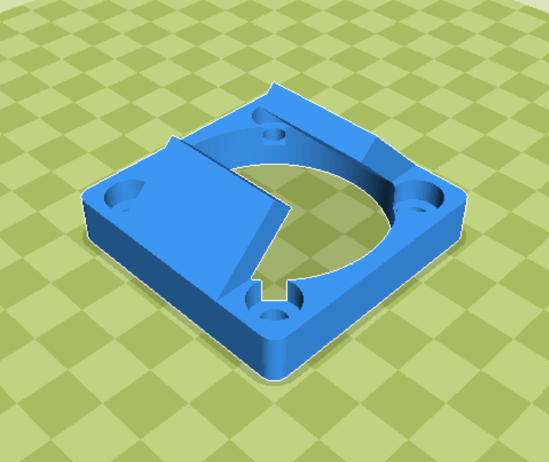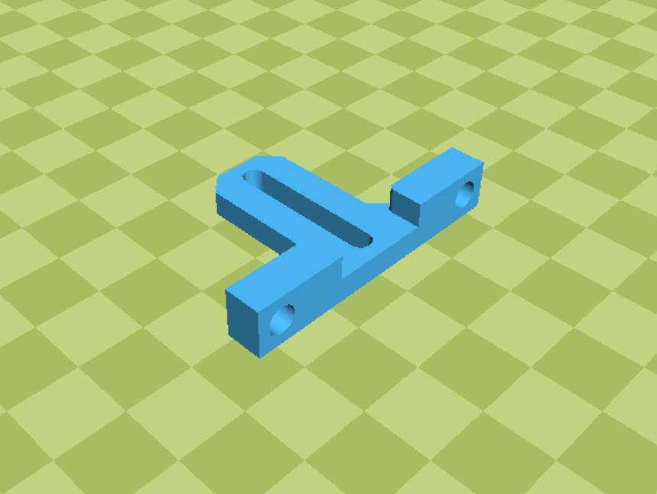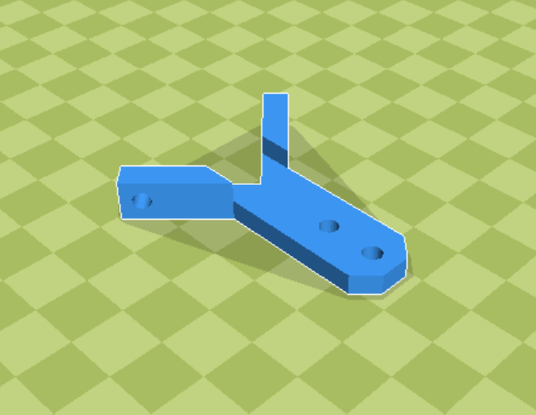

Cooling_Aluminum Trough Holders Top_x2

Cooling_Aluminum Trough Holders Bottom_x2

Cooling_Aluminum Trough Fan Mount_x4

# Diameter Sensor Assembly

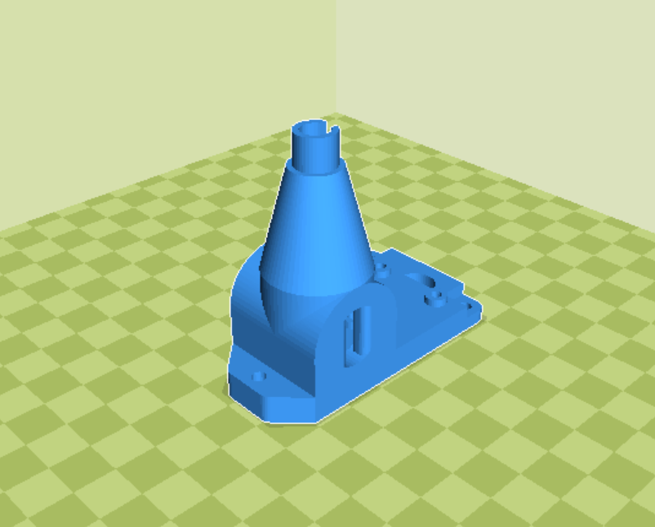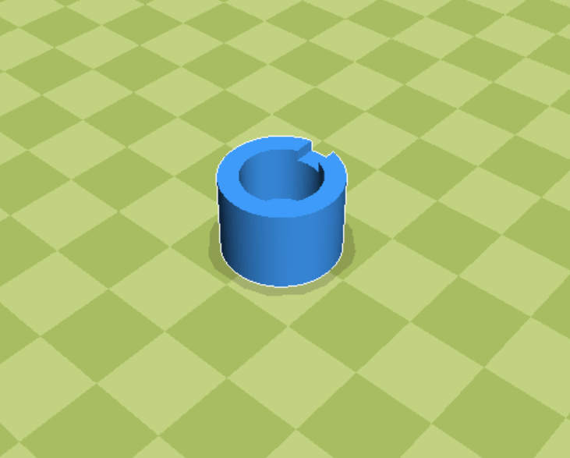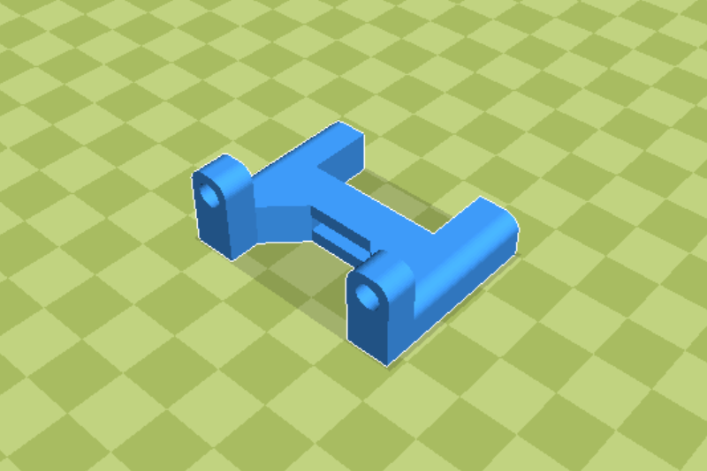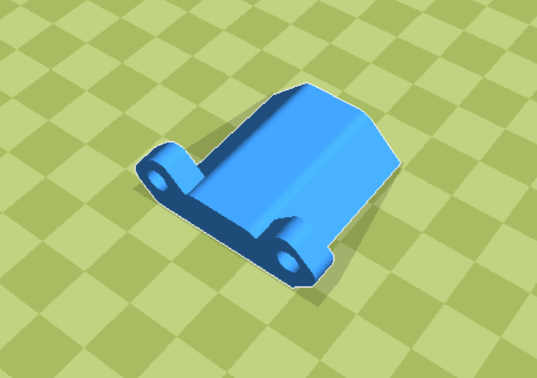

Diameter Sensor_Cap_x1

Diameter Sensor_Body_x1

Diameter Sensor_Legs_x1

Diameter Sensor_Single Leg_x1

# Extrusion Assembly

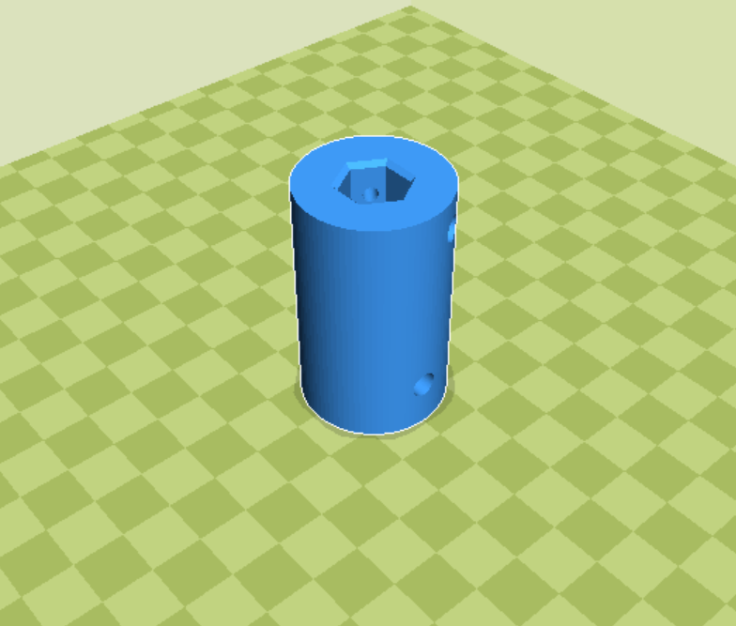

Extrusion_Auger Coupler_x1

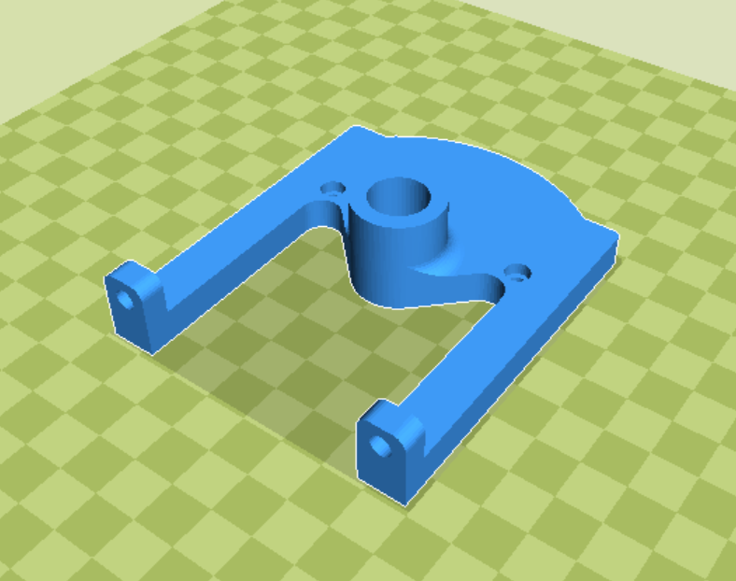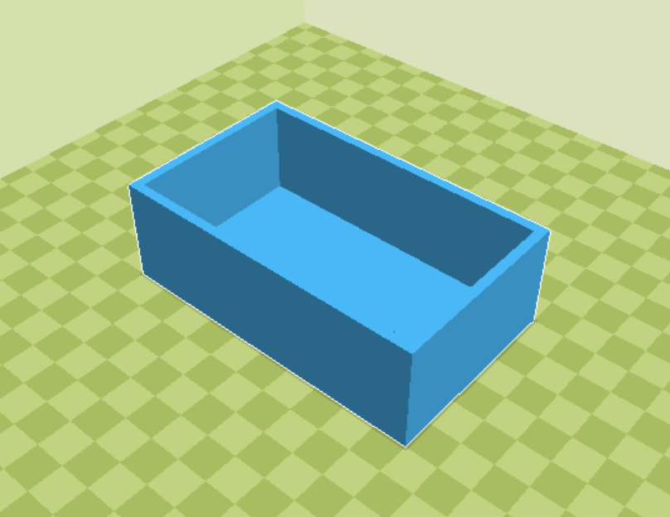

Extrusion_Hopper Catch Bin_x1

Extrusion_Hopper Feet_x1

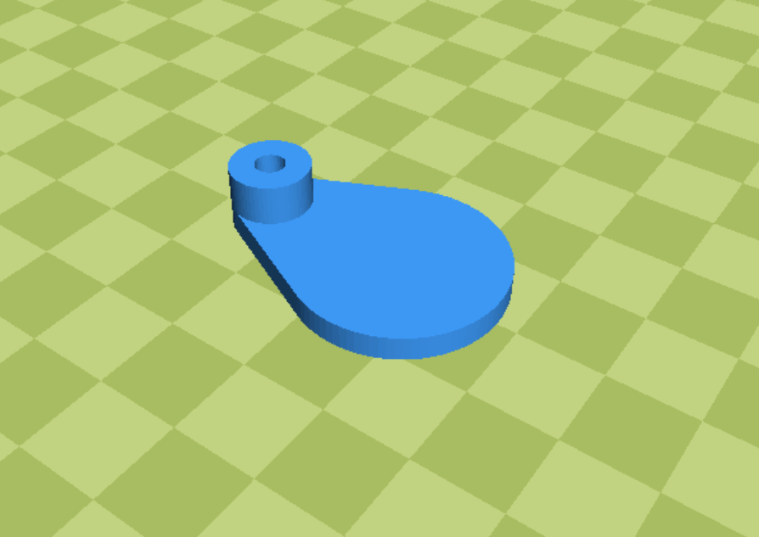

Extrusion_Hopper Hole Cover_x2

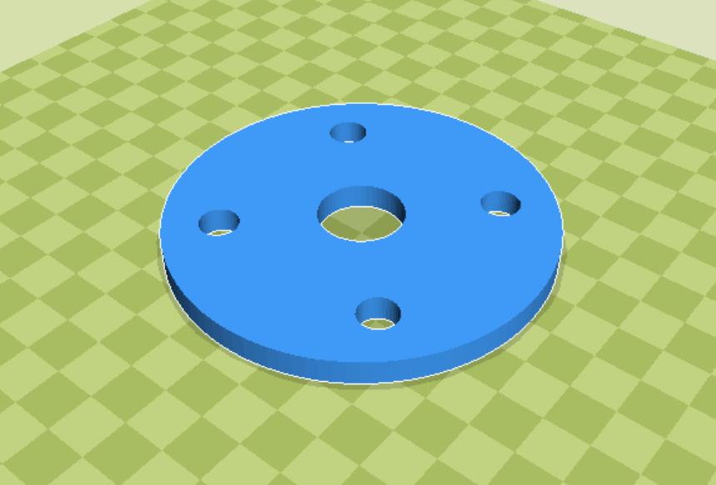

Extrusion_Hopper Insulation_x1

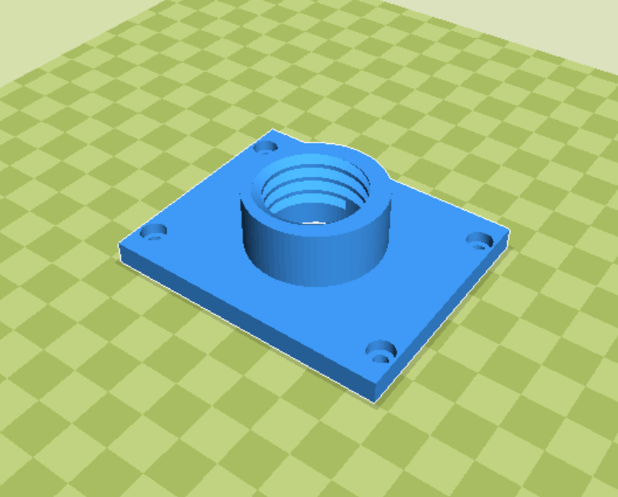

Extrusion_Hopper Screw Cap_x1

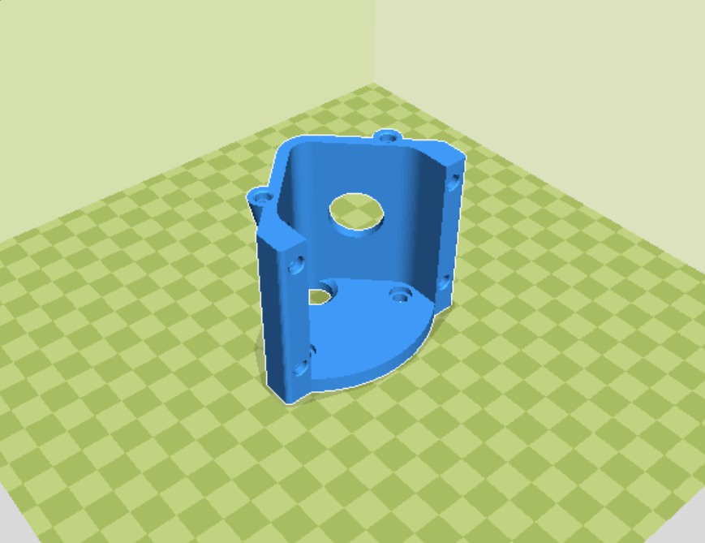

Extrusion_Hopper Trough_x1

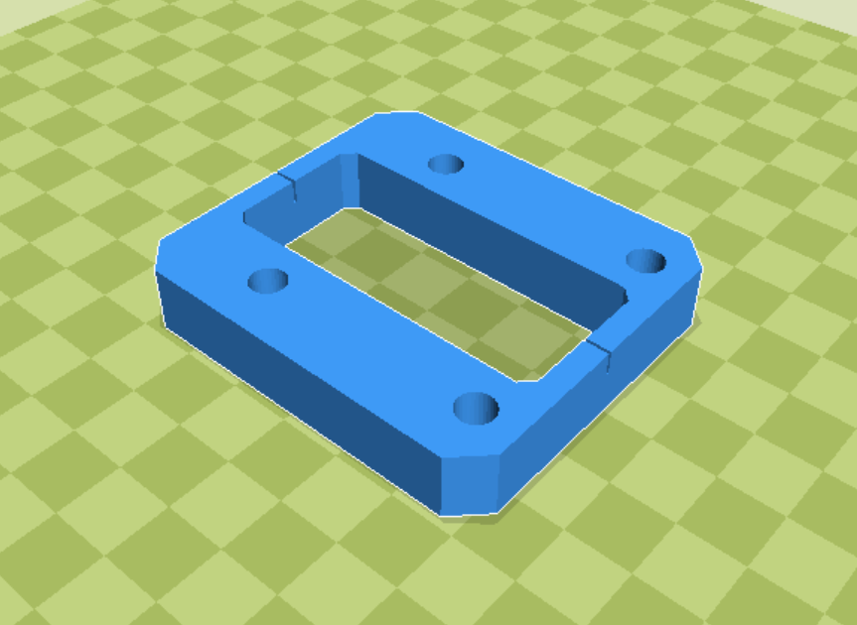

Extrusion_Motor Template_x2

# MISC Components

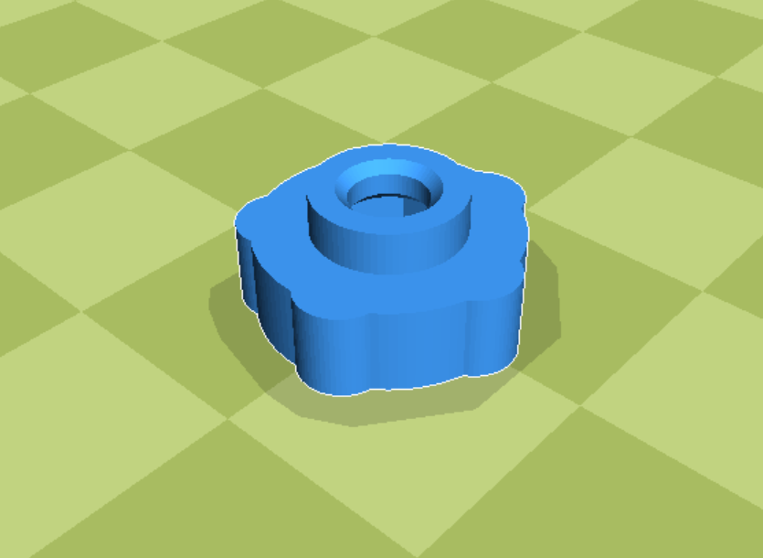

MISC_M3 Thumb Screw Conversion_x12

# Power Supply Assembly

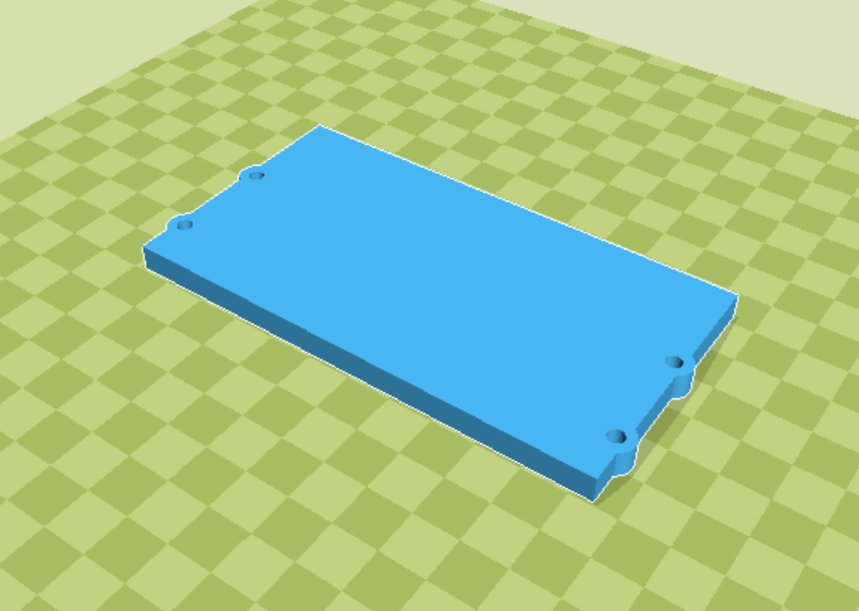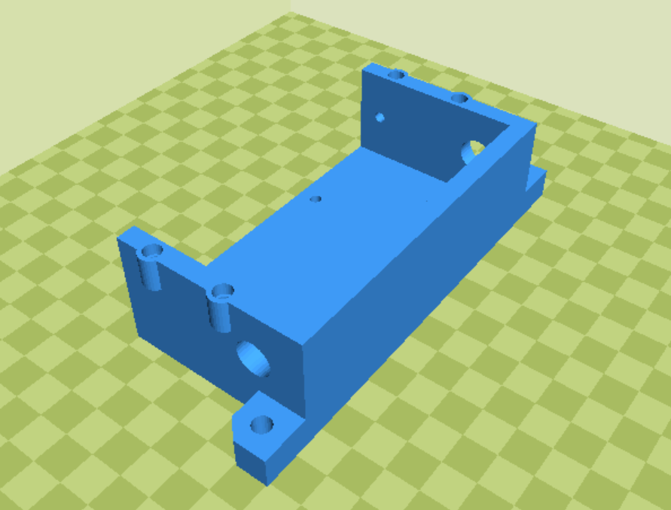

Power Supply_Mount_x1

Power Supply_Cover_x1

# Puller Assembly

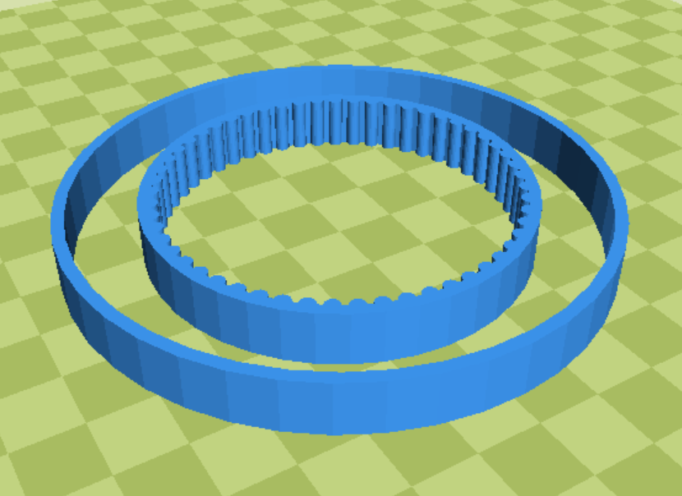

Puller&Spooler_Belts_x1 (Ninjaflex)

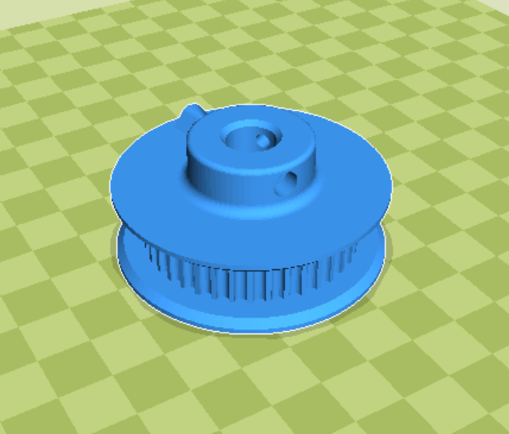

Puller&Spooler_Large Belt Pulley_x2

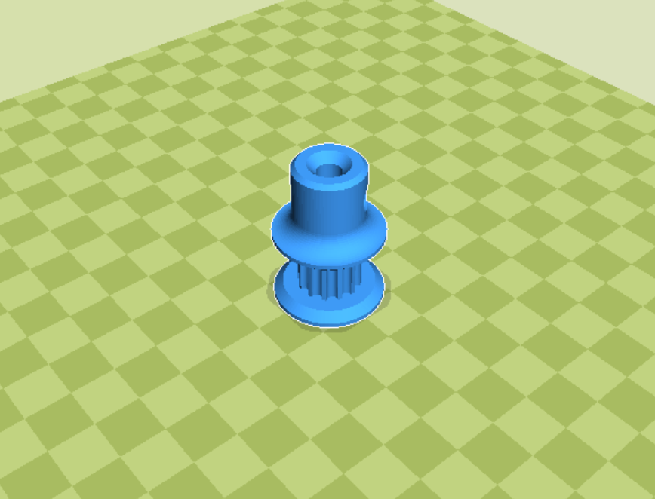

Puller&Spooler_Small Belt Pulley_x2

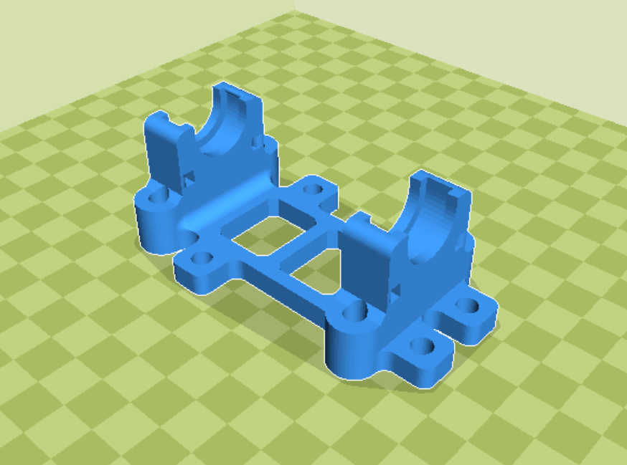

Puller_Base_x1

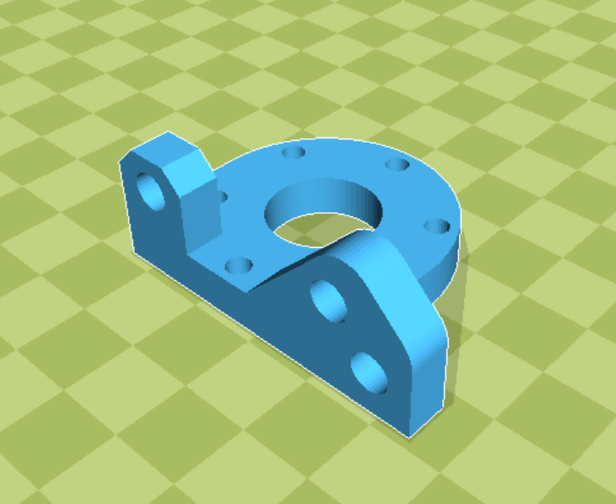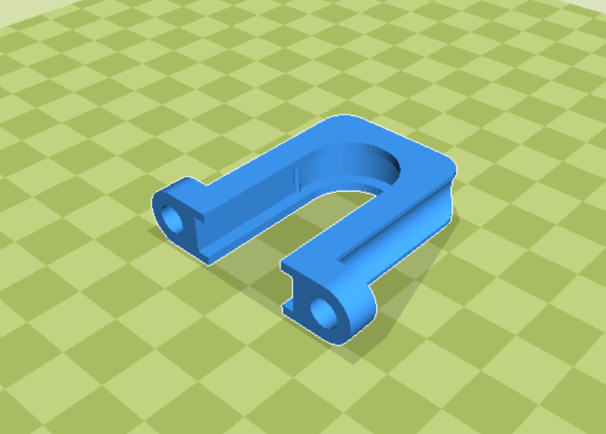

Puller_Top Bearing Holder_x2

Puller_DC Motor Mount_x1

# Roller Assembly

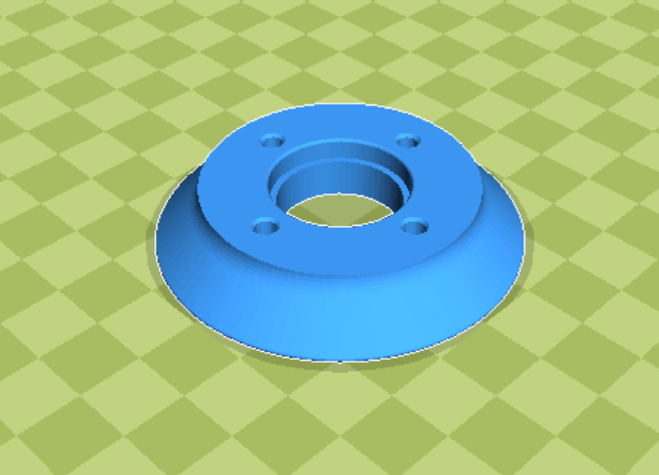

Roller_Half 1_x2

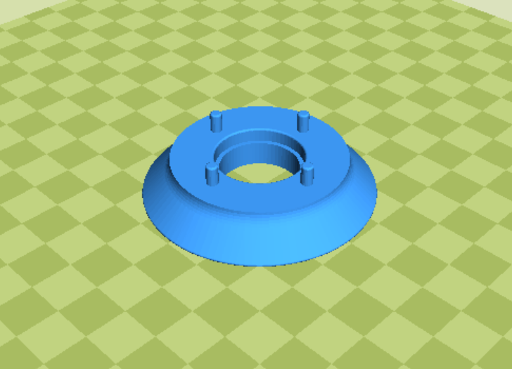

Roller_Half 2_x2

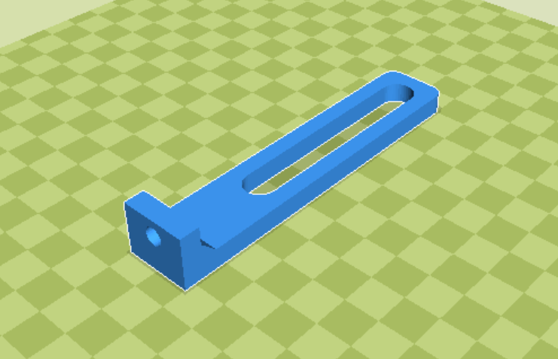

Roller_Wood Mount_x1

# Spooler Assembly

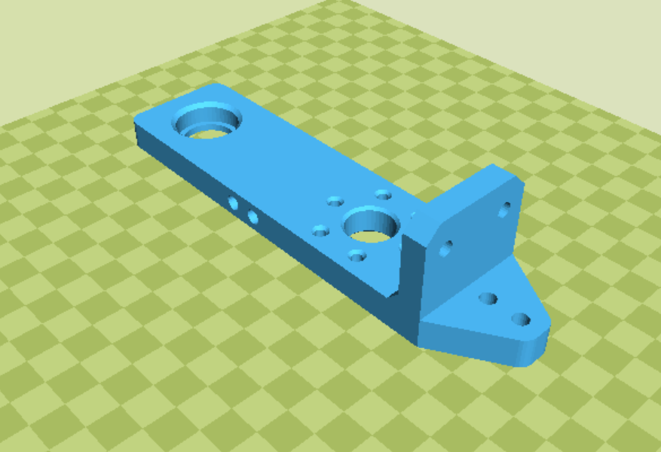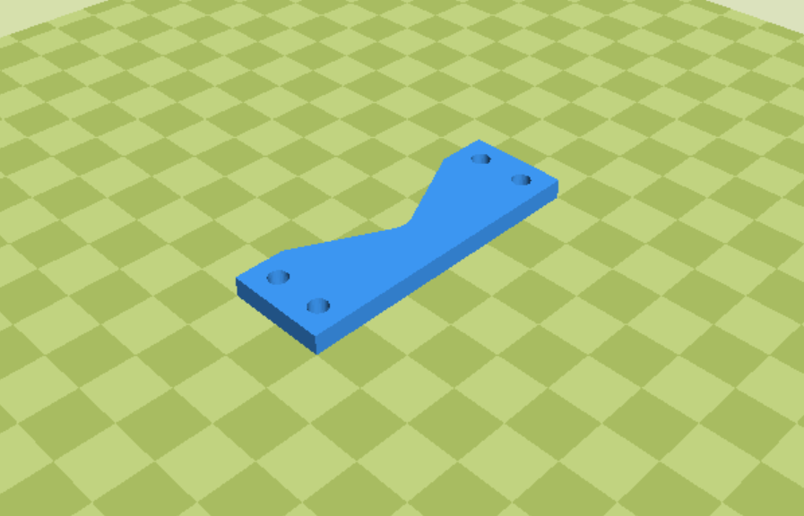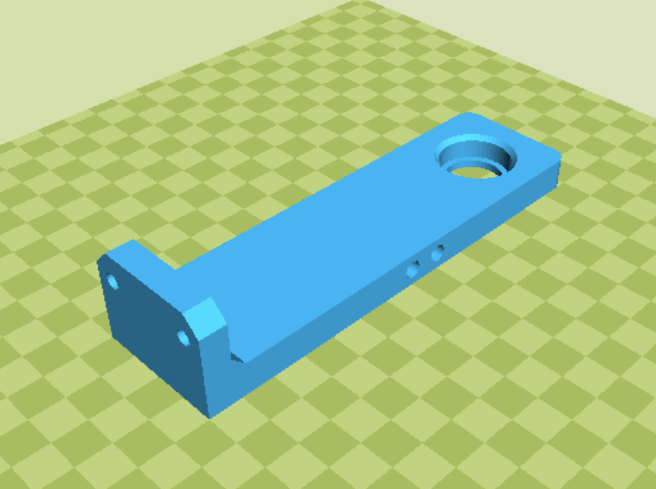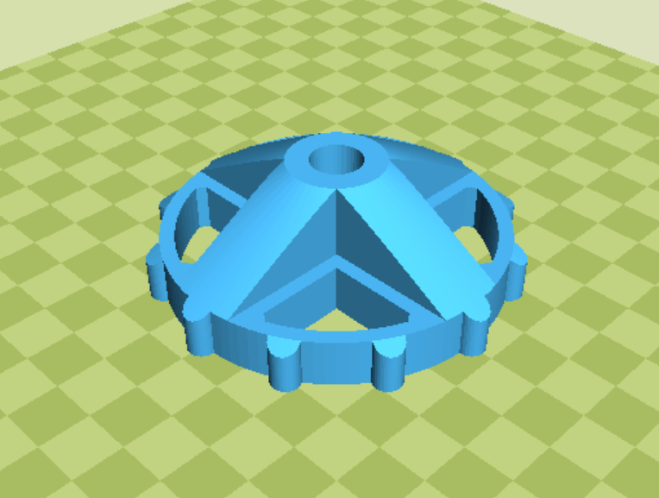

Spooler_Cross Beam_x2

Spooler_Back Bearing Tower_x1

Spooler_Hub_x2

Spooler_Front Bearing Tower_x1

# Traverse Assembly

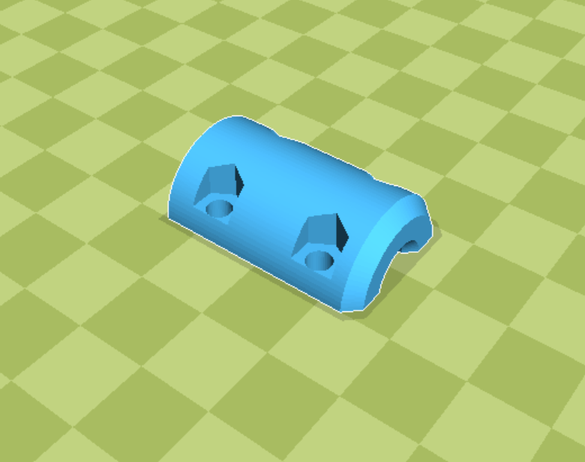

Traverse_Coupler Half_x2

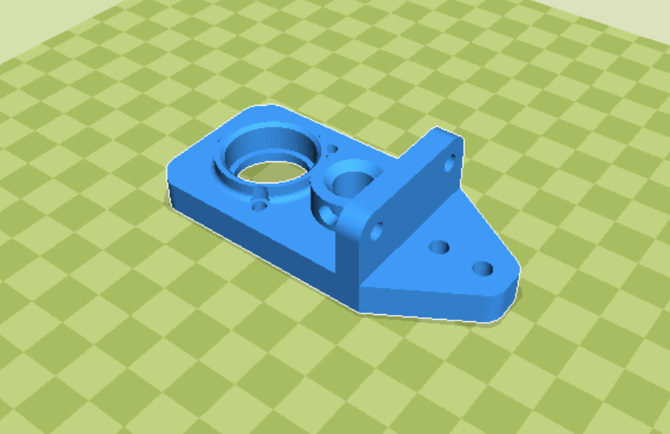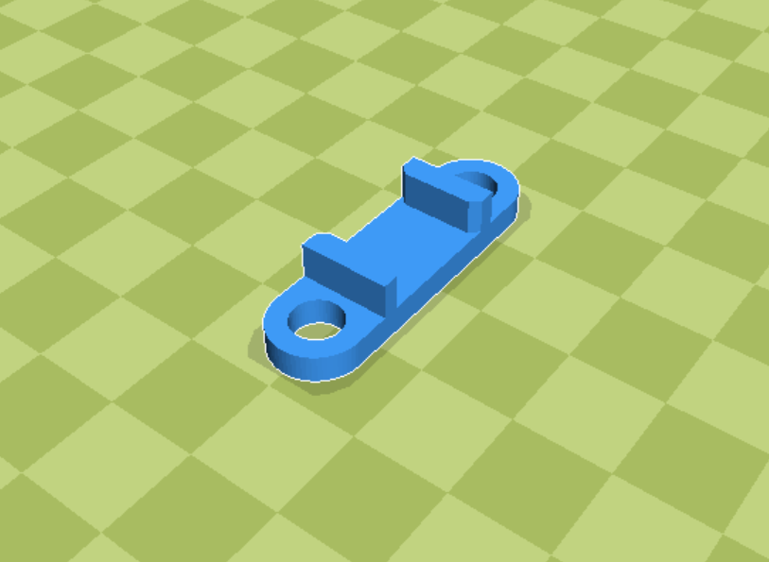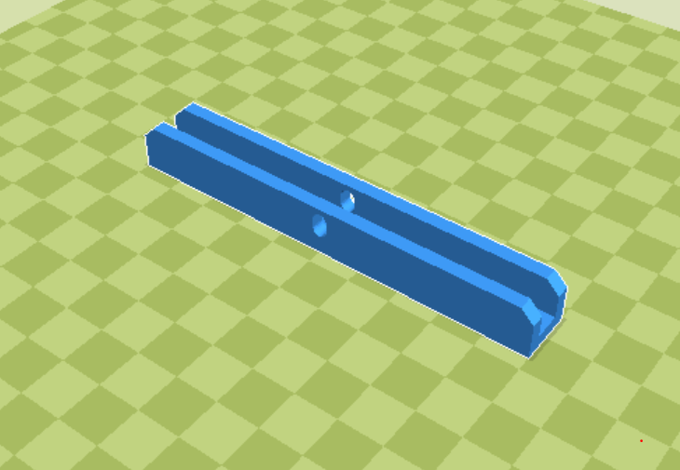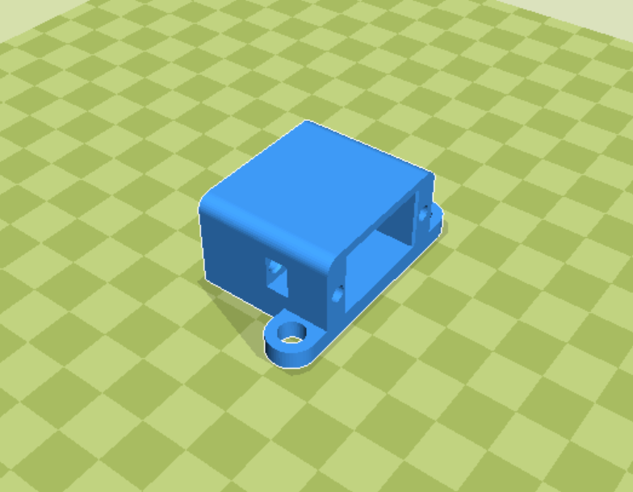

Traverse_Slider Guide_x2

Traverse_Motor and Bearing Mount_x2

Traverse_Slider_x1

Traverse_Switch Housing_x1

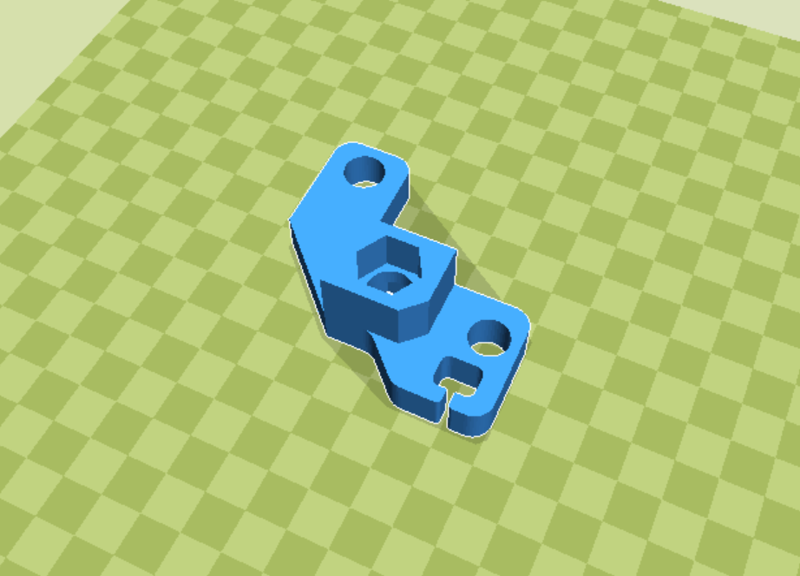

Traverse_Threaded Rod Cart_x1

# Wiring Assembly

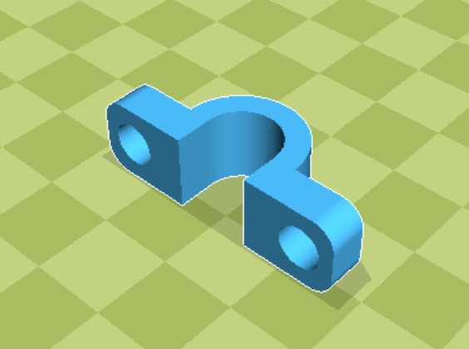

Wiring_Loom Mounts_x14